**SMART PARKING**

**Project Definition**:

The project involves integrating IoT sensors into public transportation vehicles to monitor ridership, track locations, and predict arrival times.

The goal is to provide real-time transit information to the public through a public platform, enhancing the efficiency and quality of public transportation services.

This project includes defining objectives, designing the IoT sensor system, developing the real-time transit information platform, and integrating them using IoT technology and Python.

**Design Thinking:**

**Objectives:**

Smart parking solutions are intended to give drivers complete control of their journey - from start to finish - without having to hunt for parking. The IoT technology helps save costs and minimize travel time. IoT forms the foundation for real-time data collection and analysis.

**Description:**

Smart Parking is a parking strategy that combines technology and human innovation in an effort to use as few resources as possible—such as fuel, time and space.

**working of smart parking:**

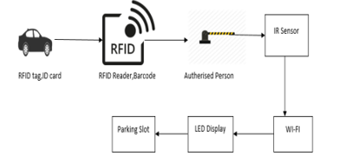

**planing:**

**Every car had unique rfid id card and its also had a barcode with corresponding rfid card.The rfid id send to the authorised person with the help of wifi ,the person have a IRsensor to check the barcode .If the barcode is correct for authorising then the setting of LED will displyay to the corresponding ploting area.**

**Real time usage:**

An IoT-based smart parking system is a decent solution for businesses and consumers, providing real-time data on parking space availability, pricing, payments, and more.

**Advantages**:

Optimized parking.

Reduced traffic.

Reduced pollution.